Visualizing Information Architecture
Tyler Daniels
Southern New Hampshire University
CS-560
Professor Palmer
10-11-26

Visualizing Information Architecture

Core Screens and Features
The celebrity chef website is designed to provide visitors with an easy way to explore recipes, learn about the chef, and access information about upcoming events and other content. The homepage serves as the main starting point and connects visitors to seven primary sections, including Recipes, About, Media & Content, Books & Publications, Events & Classes, Press & Media, and Contact & Newsletter. Each section contains related pages that help visitors find information without having to navigate through unrelated content. For example, the Recipes section includes a search feature along with different recipe categories such as breakfast, appetizers, soups, salads, main courses, and desserts. This allows visitors to either search for a specific recipe or browse based on the type of food they are interested in preparing.
The website also includes several features that allow visitors to learn more about the chef and interact with their content. The About section provides information about the chef's personal story, culinary philosophy, and professional achievements. Visitors can also explore cooking videos, podcast episodes, blog articles, restaurant reviews, and behind-the-scenes photos through the Media & Content section. Other features include a cookbook collection, publications, upcoming speaking events, cooking class schedules, and private event booking. The website also provides a press kit and information about media appearances for journalists or other professionals. These features were organized into separate categories to make the website easier to understand while still providing access to everything the chef wants to share.

Information Architecture and Visual Site Map
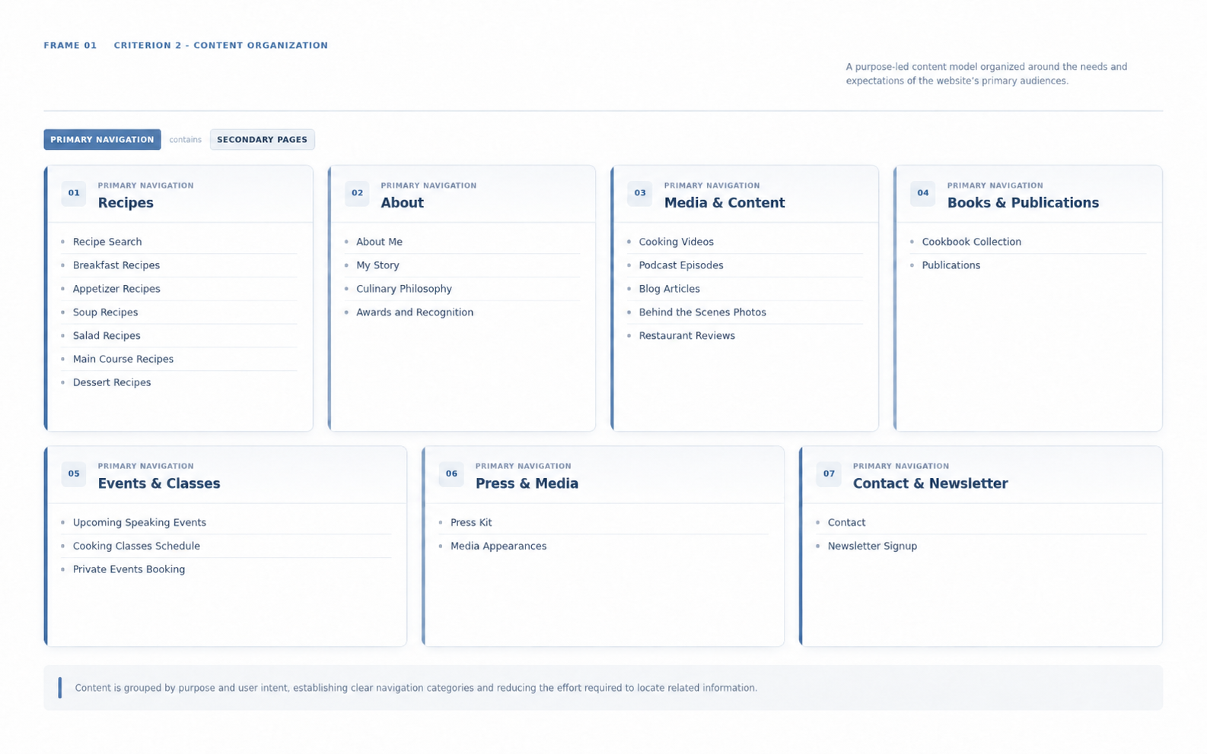
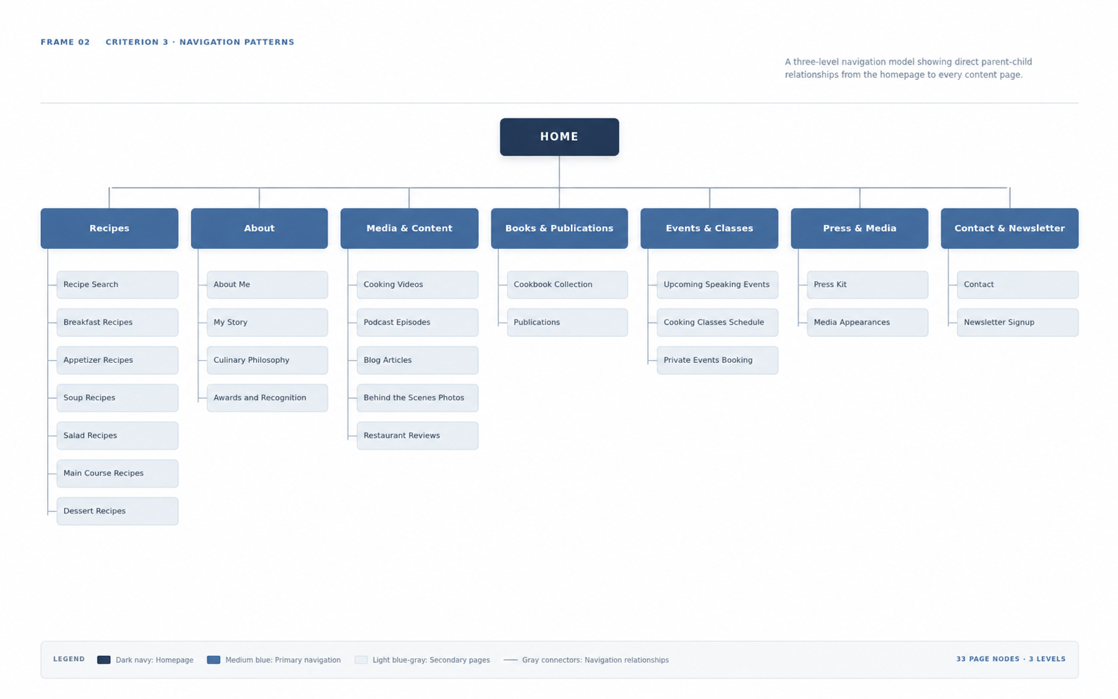
Figure 1. Information architecture showing the organization of the website's primary categories and related pages.
Figure 2. Visual site map showing the relationship between the homepage, primary navigation categories, and secondary pages.

Site Map Evaluation
When creating the site map, I focused on making the overall structure clear and easy to follow. I wanted visitors to be able to understand where different types of information were located without having to spend too much time searching. The homepage is positioned at the top of the hierarchy, followed by the seven main navigation categories and their related pages. I grouped similar features together so that the main navigation would not become overcrowded. For example, instead of placing cooking videos, podcast episodes, blog articles, and restaurant reviews directly on the main navigation, I organized them under Media & Content. This allows visitors to explore related material in one location while keeping the overall website structure simple.
I also considered the visual balance of the site map by using consistent spacing, colors, and labels throughout the design. Each level of the hierarchy uses a different color to help distinguish between the homepage, primary navigation, and secondary pages. The connecting lines help show how the pages relate to one another and how visitors would move through the website. One area that could be improved in the future would be testing the navigation with actual users to see whether the categories make sense to them. Some visitors might expect certain content to appear under a different section, so gathering feedback would help identify any confusing areas. Overall, I believe the site map provides a clear structure that could be used as a foundation for the website's future development.

Supporting User Needs and Information Architecture Principles
The structure of the website was designed with different types of visitors in mind because not everyone will be visiting for the same reason. Someone who enjoys cooking might visit the website to find a new recipe or watch a cooking video, while another person might be interested in learning more about the chef's background or purchasing a cookbook. Visitors looking for cooking classes or private event booking information can find those features under Events & Classes. Journalists and media professionals can also locate press materials and previous media appearances without having to search through unrelated sections. By organizing the website around these different needs, visitors should be able to find what they are looking for with fewer steps.
Throughout the design process, I applied several information architecture principles, including hierarchy, logical grouping, consistent labeling, and clear navigation. The hierarchy helps establish which pages are the most important, while the secondary pages provide more specific information within each category. I also tried to use straightforward labels so visitors could understand what each section contains before selecting it. Keeping similar content together helps reduce confusion and makes the website feel more organized. I believe this structure would make the website easier to navigate while also allowing additional pages or features to be added in the future without having to completely redesign the navigation. The main goal was to create a website structure that feels natural to visitors and allows them to focus on the content they came to find.

